**The POI classification system (Table 2) is constructed by the principle of guaran-teeing basic living, combined with the living environment of the city, with reference to the classification system of other scholars (Yao et al., 2017). We divide the POI data into 15 categories. This article has filtered the address POI points and merged the 'motorcy-cle service,' 'car sales,' and 'car repair' into the automobile service.**

**Table 2.** The POI classification system

|  |  |
| --- | --- |
| **Category** | **Indicator interpretation** |
| Automobile service | Gas stations, car sales, car repairs, private parking lots and public parking lots, parking spaces, auto repair shops, auto 4s shops, etc., providing convenient services for private transportation, etc. |
| Catering service | Catering-related places, Chinese restaurants, foreign restaurants, fast food restaurants, casual restaurant places, cafes, tea houses, cold drinks shops, pastry shops, dessert shops, etc. |
| Shopping service | Shopping malls, convenience stores/convenience stores, home appliance electronics stores, supermarkets, home building materials market, stationery stores, sports goods store services, shoes, and hats, leather goods stores, personal products/cosmetic stores, etc. |
| Public facilities | Public toilets, fund shelters, newsstands, public telephones, etc. |
| Life service | Life service place, travel agency, information consultation center, ticket office, post office, express flow express, telecommunications business hall, office, water supply business hall, electric power business hall, etc. |
| Sports and leisure service | Sports and leisure service places, sports venues, entertainment venues, holiday resorts, leisure venues, theaters, etc. |
| Healthcare service | It mainly includes first-, second-, and third-level hospitals, community clinics, private clinics, private hospitals, pharmacies, general hospitals, specialist hospitals, emergency centers, etc. |
| Accommodation service | Accommodation services, hotels, hotel guest houses, etc. |
| Scenic spots | Including comprehensive parks, zoos and botanical gardens, children's parks and gardens, etc., providing places for residents to enjoy, watch, relax, and enjoy scenic spots. |
| Business residence | Business housing-related, industrial parks, buildings, residential areas, etc. |
| Government agencies and social groups | Government agencies, traffic vehicle management, industrial and commercial tax authorities, democratic parties, public security agencies, foreign institutions, government and social organizations, and social organizations |
| Education culture service | Science and education cultural sites, museums, convention centers, art galleries, libraries, science and technology museums, planetariums, cultural palaces, literary and art groups, media organizations, schools, research institutions, training institutions, etc. |
| Transportation facilities service | Airport related, railway station, long-distance bus station, subway station, light rail station, bus station, shuttle bus station, parking lot, border port, taxi, ferry station, ropeway station, road auxiliary facilities, warning information, toll station, service area, traffic lights, street signs, etc. |
| Financial and insurance service | Financial and insurance services, banks, ATMs, insurance companies, securities companies, finance companies, etc. |
| Companies and enterprises | Company companies, companies, factories, agriculture, forestry, animal husbandry, etc. |

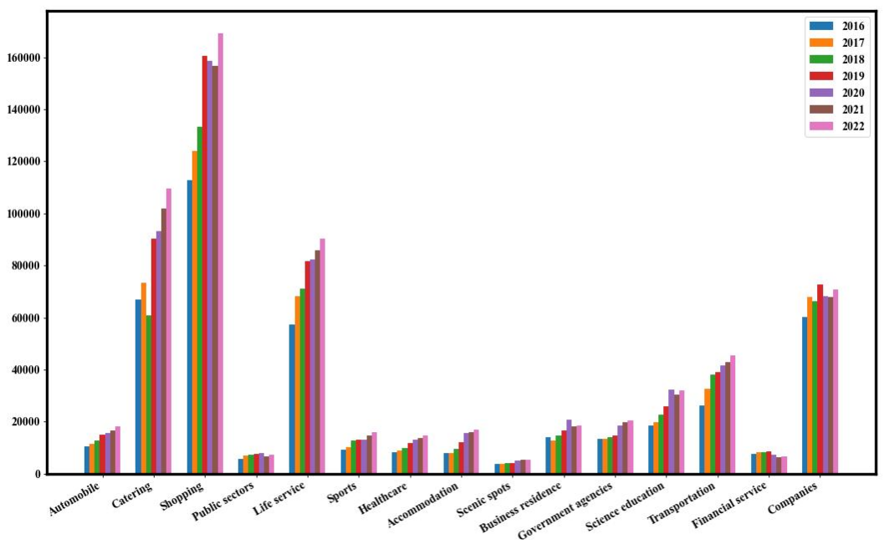

**Fig 10**. Temporal trends of fifteen types of POI in Nanjing (2016-2022).